**LUH TYLER RELEASES HIGHLY-ANTICIPATED DEBUT ALBUM *MR.SKII***

**15-TRACK PROJECT FEATURES KODAK BLACK, BOSSMAN DLOW, BLP KOSHER, VEEZE AND TRAPLAND PAT**

[**DOWNLOAD/STREAM *MR.SKII***](https://luhtyler.lnk.to/Mr.Skii)

**FANS CAN CATCH LUH TYLER AT IN-STORE POP UPS IN MIAMI, ATLANTA AND HOUSTON**

**LAUNCHES INTERACTIVE GAME EXCLUSIVELY AT** [**WWW.REALYLUHTYLER.COM**](http://www.realyluhtyler.com)

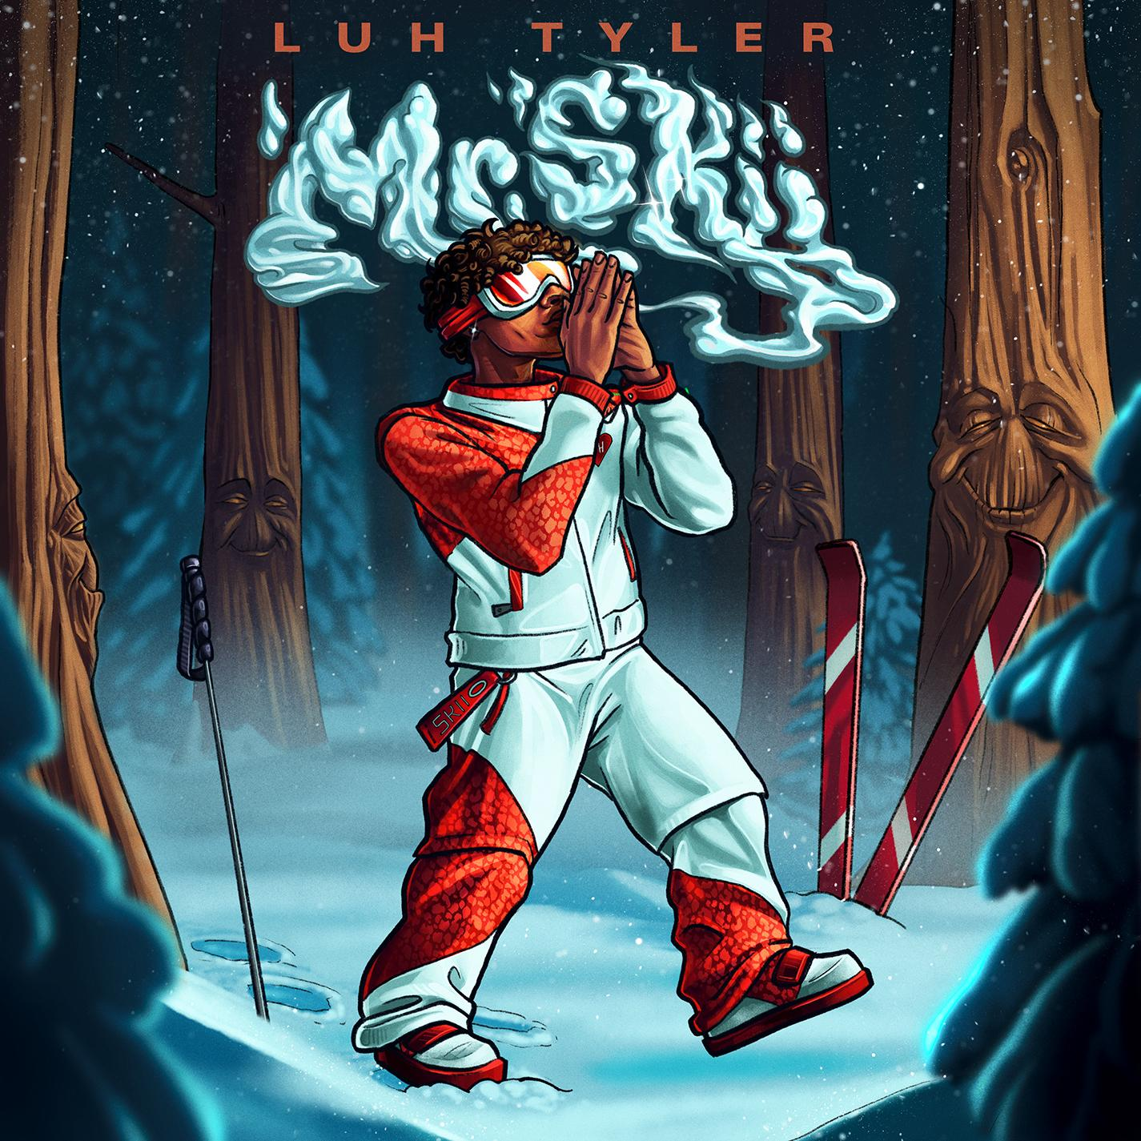

[DOWNLOAD HI-RES ARTWORK + PRESS IMAGES](https://press.atlanticrecords.com/luh-tyler)

**MR. SKII TRACKLIST**

Been Working

Met Gala

Ocean

Stick 2 The Code

Young N****a

7 AM In Munich featuring Kodak Black

TH2DH

Mr. Skii

Open The Door featuring Veeze

Change My Wayz

2 Slippery featuring BossMan Dlow

First Show

Stayed Down featuring BLP Kosher & Trapland Pat

Ain’t Come to Chill

Gotta Lose To Win/What You Think Now

**LUH TYLER IN-STORE POP UPS**

August 23rd - Miami/Ft. Lauderdale: Technique Sounds @ 6:30 PM

August 26th - Atlanta: DBS Sounds @ 5 PM

August 28th - Houston: Cactus Music @ 5 PM

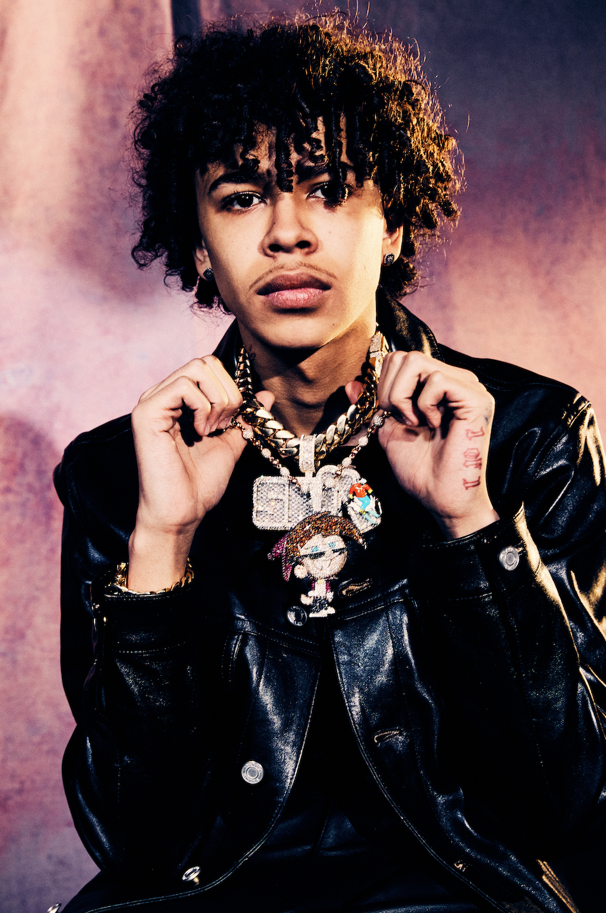

[DOWNLOAD HI-RES ARTWORK + PRESS IMAGES](https://press.atlanticrecords.com/luh-tyler)

# # #

**For all Luh Tyler press inquiries, please contact:**

Jason Davis | Jason.Davis@atlanticrecords.com

**ABOUT LUH TYLER**

Wielding a wavy flow, irresistible melodies, and inventive dynamics, Luh Tyler animates bouncy anthems with undeniable unpredictability. He switches lanes seamlessly between his signature laidback cadence and airy high register, touting a style all his own. It’s why he’s quietly emerged as a vibrant voice out of his native Tallahassee, FL all before the age of 16. Inspired by local favorites Wizz Havin, Trapland Pat, L.O.E. Shimmy, and more, he started to upload music of his own. Following“5 On It Freestyle,” he gained traction with “Jayda Wayda.”Meanwhile, “Law & Order” posted up 3.9 million YouTube views. Pitchfork hailed “I Gotta Slide” among “The Ones” and professed, *“I particularly like moments when his voice cracks or sounds dry; it makes lines stick in your mind.”*

During late 2022, he popped off with “Back Flippin,” reeling in 1 million Spotify streams and 1.4 million YouTube views bolstered with support from the likes of Jordan Rose and Pitchfork, *“Luh Tyler’s music is uncannily natural. Just low-stakes tracks with punched-in lyrics over airy beats.”* Meanwhile, he attracted the attention of Atlantic and landed a deal with the label.   
  
In 2023, Tyler released his debut Mixtape, *My Vision* which debuted #2 on Billboard's Heatseeker’s chart and was praised by the likes of Billboard, Pitchfork, Complex and more. He has since landed on the coveted XXL Freshman Cover and has been named to Billboard's *21 Under 21 List.*   
  
Tyler returned this year with his debut album *Mr. Skii*, produced by xx and featuring Kodak Black, BossMan Dlow, BLP Kosher, Veeze, and Trapland Pat.