FOR IMMEDIATE RELEASE

OCTOBER 18, 2024

**THE HELLP HERALD HUGELY ANTICIPATED DEBUT ALBUM WITH “STUNN”**

**ALBUM *LL [UNTITLED]* ARRIVES ON FRIDAY, OCTOBER 25**

**BIGGEST US TOUR TO DATE BEGINS OCTOBER 30TH**

**WITH TWO SOLD OUT NIGHTS IN SAN FRANCISCO**

**“STUNN” AVAILABLE NOW VIA ANEMOIA RECORDS/ATLANTIC MUSIC GROUP**

**LISTEN TO “STUNN” |** [**PRE-ORDER/PRE-SAVE *LL [UNTITLED]***](https://thehellp.lnk.to/presaveLL)

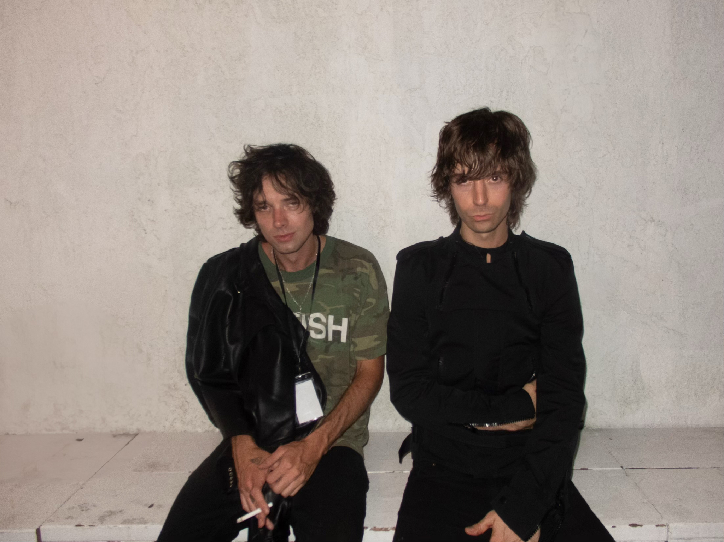

[DOWNLOAD](https://warnermusicgroup.box.com/s/s6nmzjk9bzvl0r0xukoe3pelthg01pd8) HI-RES COVER ART // [DOWNLOAD HI-RES PRESS PHOTO](https://warnermusicgroup.app.box.com/s/e7yjd1p5fzvkpmht2rhp3zq2qaj49f93)

(L-R: CHANDLER RANSOM LUCY, NOAH DILLON)

*“The Hellp could be the last cool band on earth.” –* **THE FACE**

*“The Hellp are the gold standard…their show in NYC was one of the best I’ve ever been to…their music is just leaps and bounds above everyone else’s and are ushering in the next evolution of punk.” –* **NO BELLS**

*“The Hellp have electrified dance floors and basements alike with their post-pop punk meets indie sleaze-esque pump-up sonic stratosphere.” –* **PAPER**

*“The Hellp’s knack for emotive storytelling within the electroclash genre, promising a compelling addition to their repertoire.” –* **NOTION**

Acclaimed indieicons **The Hellp** have shared their staggering new single, “**Stunn**,” available now via Anemoia Records/Atlantic Music Group HERE. The track heralds next week’s release of the duo’s hugely anticipated debut album, [***LL [untitled]***](https://thehellp.lnk.to/presaveLL), arriving everywhere on Friday, October 25. Pre-orders/pre-saves are available now [HERE](https://thehellp.lnk.to/presaveLL).

*LL [untitled]*also includes such acclaimed singles as “[Caustic](https://thehellp.lnk.to/caustic),” joined by a striking official music video weaving found footage filmed on the last day of school at California’s Calabasas High School in 2008 with previously unseen clips of The Hellp – a.k.a. **Noah Dillon and Chandler Ransom Lucy** – captured during the earliest days of the band’s career. “Caustic” is streaming now at [YouTube](https://www.youtube.com/watch?v=JBmQzURj15Q) following its exclusive premiere via [***PAPER***](https://www.papermag.com/the-hellp-caustic#rebelltitem4), which raved, “*Hitting both nostalgic and futuristic elements with their sound, the duo has built a loyal fanbase of dance-driven delinquents who eat up their introspective and referential output.*”

*LL [untitled]* is further highlighted by the critically lauded “[Colorado](https://thehellp.lnk.to/Colorado),” available now [HERE](https://thehellp.lnk.to/Colorado). Co-written and co-produced by The Hellp with Chris Greatti (Poppy, Grimes) and Liam Hall (Yungblud, EarthGang), the exhilarating track is joined by an official music video streaming now at YouTube [HERE](https://thehellp.lnk.to/ColoradoVid).

“Colorado” drew ecstatic praise from an array of influential outlets, including [***No Bells***](https://nobells.blog/the-hellp-interview/), which hailed the track’s “*tender pop sensibilities*,” adding, “*It’s a mechanical symphony; swarms of digitized chirps bleed onto drums working to slice your skull open, but at the same time it’s blissful and euphoric making you want to hug the person next to you as it all unfolds.*” “*The song’s blend of melancholy and momentum captivates,*” wrote ***NOTION***, “*echoing themes of longing and introspection against a backdrop of vivid imagery.*” “Colorado” is “*a testament to (The Hellp’s) passionate storytelling within the electroclash genre*, *exuding a fuzzy warmth and embracing their tongue-in-cheek indie sleaze aesthetic,*” wrote ***Ones To Watch***, while also declaring, “*The dynamic, cinematic visual…directed by Dillion himself, is a thrill ride from start to finish.*”

In addition, *LL [untitled]* includes the powerful “[Go Somewhere](https://www.youtube.com/watch?v=4YVCymt59JE&ab_channel=THEHELLP),” which made its striking debut last month alongside a thought-provoking and controversial companion video streaming now at YouTube [HERE](https://www.youtube.com/watch?v=4YVCymt59JE&ab_channel=THEHELLP) following its premiere last month at New York City contemporary art gallery, The Hole, and subsequent DJ set as part of Affliction X Rogue’s New York Fashion Week rave at Brooklyn’s SILO. Please note: the “Go Somewhere” video overtly deals with themes of self-harm, suicide, gun violence, death, and dying which some individuals may find distressing. Viewer discretion is advised.

The Hellp will mark the arrival of *LL [untitled]* with their biggest US headline tour thus far, getting underway with a sold-out two-night stand at San Francisco, CA’s Brick & Mortar Music Hall on October 30-31. Additional highlights include dates at such vaunted venues as New York, NY’s Irving Plaza (November 11), Nashville, TN’s The Basement (November 16), and Los Angeles, CA’s Fonda Theatre (November 21). Tickets for most dates are now sold out or extremely limited; please check local listings for remaining availability.

**THE HELLP**

***USA 2024***

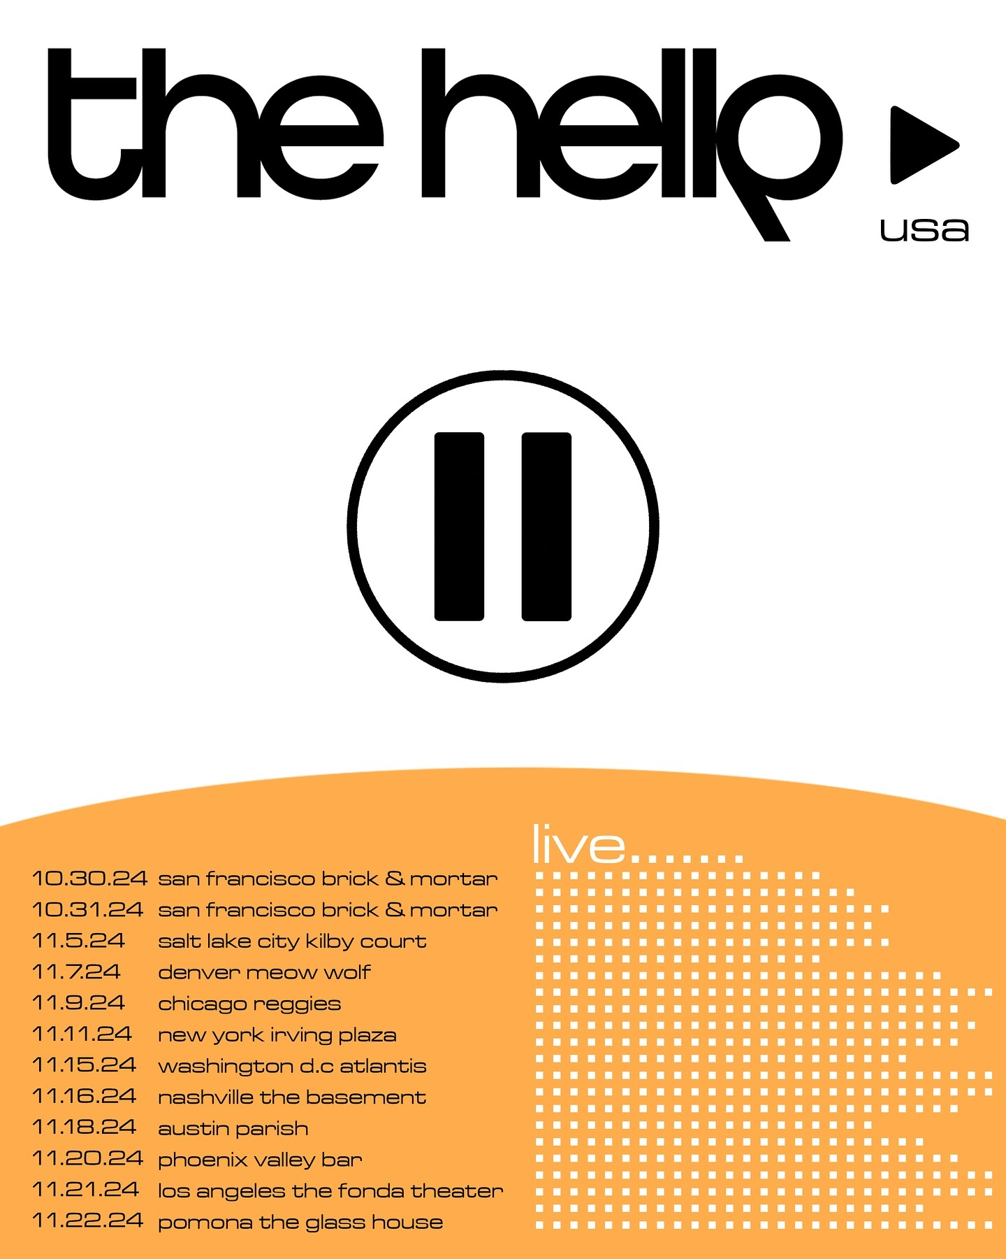

**OCTOBER**

30 – San Francisco, CA – Brick & Mortar Music Hall (SOLD OUT)

31 – San Francisco, CA – Brick & Mortar Music Hall (SOLD OUT)

**NOVEMBER**

5 – Salt Lake City, UT – Kilby Court

7 – Denver, CO – Meow Wolf

9 – Chicago, IL – Reggie’s Rock Club (SOLD OUT)

11 – New York, NY – Irving Plaza

15 – Washington, DC – The Atlantis

16 – Nashville, TN – The Basement

18 – Austin, TX – Parish

20 – Phoenix, AZ – Valley Bar (SOLD OUT)

21 – Los Angeles, CA – The Fonda Theatre

22 – Pomona, CA – The Glass House (SOLD OUT)

# # #

Hailed by *FWRD* for “*mixing eclectic rock, electronic, and country influences to craft ballads that sound like Mick Jagger and Aphex Twin’s musical lovechild from the future,*” The Hellp has quickly amassed a dedicated fan following on both coasts via their electrifying live shows and DJ sets, including sold-out performances at pop-up parties. A renowned photographer and filmmaker whose work has been commissioned by the likes of *GQ*, Balenciaga, Versace, Gucci, Nike, and more, Dillon through the ranks of the LA art scene prompting international fashion magazine *i-D* to declare, “*Noah Dillon is leading a creative revolution.*” The Hellp came together when Dillon and Lucy, an accomplished model who has starred in a number of music video and top lookbooks, met on the set of a [Hot Mess](https://www.gq.com/story/luka-sabbat-hot-mess-pusha-t-art-opening-photos) photo shoot, the art platform Dillon founded alongside model/stylist Luka Sabbat. The two formed an instant connection, bonding over a shared passion for A$AP Rocky, Bruce Springsteen’s *Nebraska*, Crystal Castles, and a shared desire to fuse sound, aesthetic, and vision into their own distinctive brand of electric pop music for a new generation.

2023 saw The Hellp make their spectacular Anemoia Records/Atlantic Records debut with “[California Dream Girl](https://thehellp.lnk.to/CaliforniaDreamGirl),” praised by *The Face* as “*a polished anthem fit for a top-down drive through Malibu*” and joined by a captivating short film, directed by Dillon and streaming now at The Hellp’s official YouTube channel [HERE](https://thehellp.lnk.to/CDGVideo). The band celebrated “California Dream Girl” with sold-out headline shows at Los Angeles’ Teragram Ballroom and New York City’s Bowery Ballroom, the latter earning applause from ***No Bells*** as “*one of the best I have ever been to*,” adding *“(The Hellp are) the gold standard…ushering in the next evolution of punk.*”

# # #

**CONNECT WITH THE HELLP**

[INSTAGRAM](https://www.instagram.com/thehellp/) | [YOUTUBE](https://www.youtube.com/@THEHELLPMUSIC)

**PRESS CONTACT**

[Paige.Rosoff@atlanticrecords.com](mailto:Paige.Rosoff@atlanticrecords.com)