FOR IMMEDIATE RELEASE

OCTOBER 1, 2024

**ROSÉ ANNOUNCES FIRST STUDIO ALBUM ‘rosie’**

**ARRIVING DECEMBER 6TH VIA ATLANTIC RECORDS**

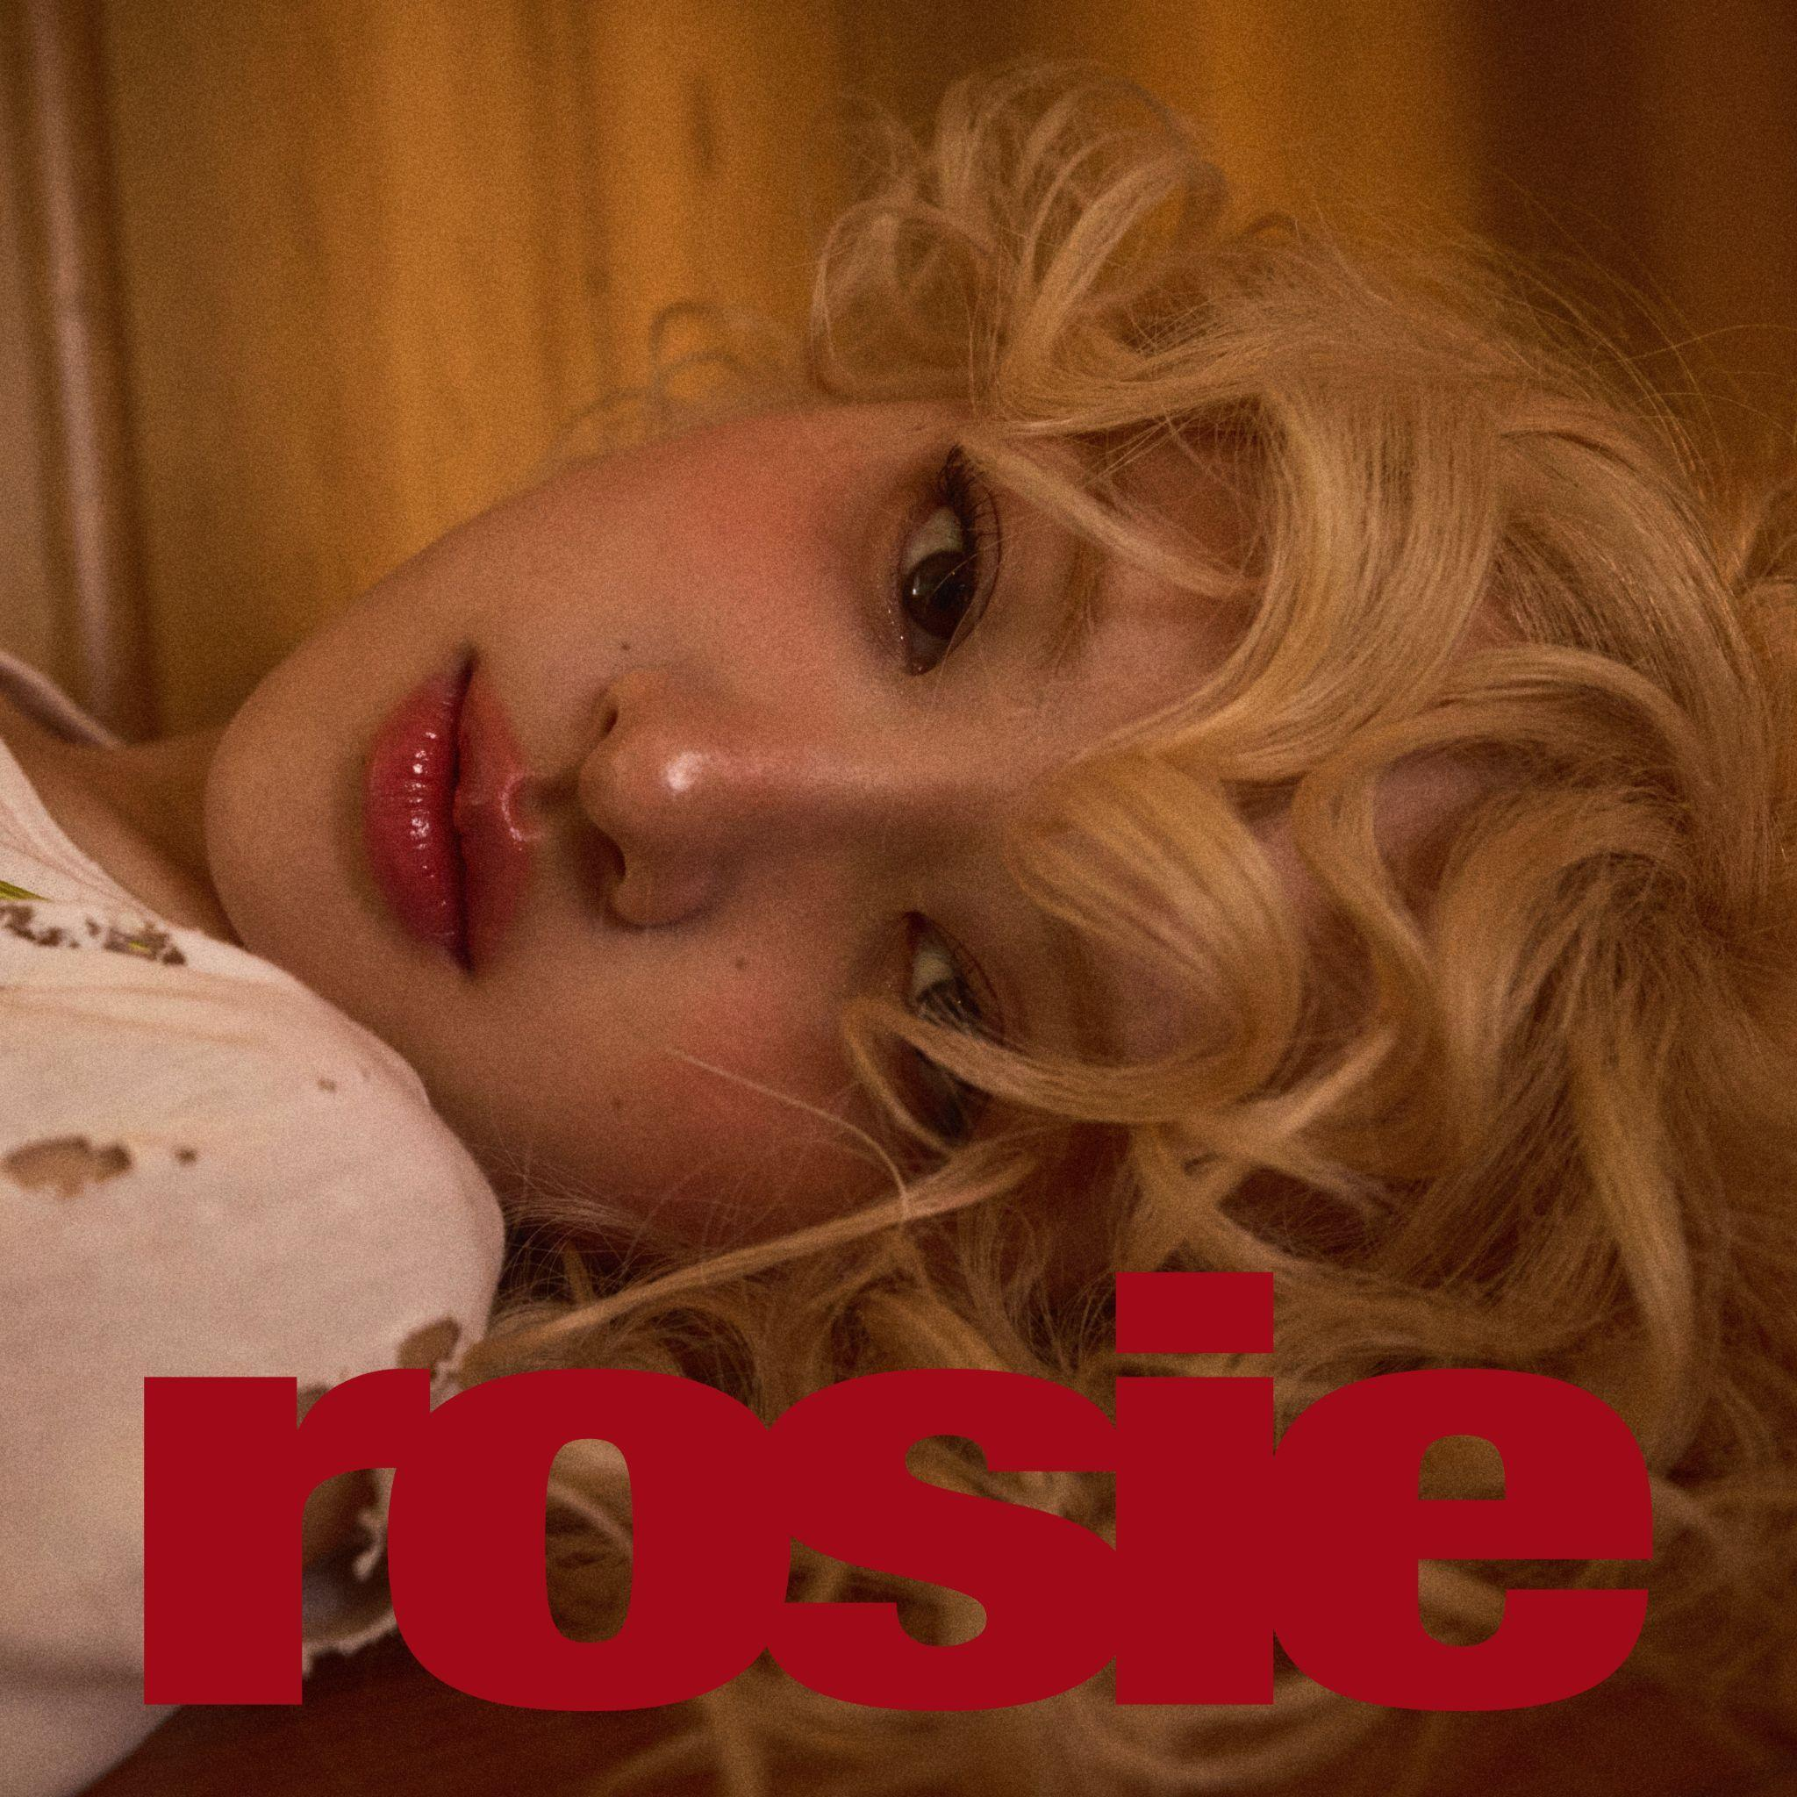

[DOWNLOAD HIGH-RES IMAGES](https://warnermusicgroup.box.com/s/90drelvfglgepqewvgq3q68zxfehaacn)

Global icon **ROSÉ** has announced her first studio album ***rosie*** - arriving December 6th via **Atlantic** **Records**. The 12-track collection marks **ROSÉ**’s most personal and candid release to date, with her co-writing and co-producing the project in its entirety. Pre-orders have launched today exclusively via her official webstore ([link](https://www.rosesarerosie.com/)), and will be available via DSPs and retailers tomorrow, October 2nd ([link](http://rosesarerosie.lnk.to/rosie)).

As a member of **BLACKPINK**, one of the best-selling girl groups of all time, **ROSÉ** has shattered records, performed on the most heralded stages, and amassed millions of fans around the world. On her own, the Korean-New Zealand superstar’s 2021 single “**On The Ground**” debuted at #1 on the Billboard Global 200 chart and became the highest-charting song by a solo K-pop female on the Billboard Hot 100. Simultaneously, **ROSÉ** has been an unstoppable force in fashion as global ambassador for renowned brands including **Saint** **Laurent**, **Tiffany & Co**, **Rimowa** and **Puma**. Her influence in music, fashion and philanthropy has led to her having over 79M followers on Instagram as she is a testament to the growth of Korean influence in music and fashion on a global scale.

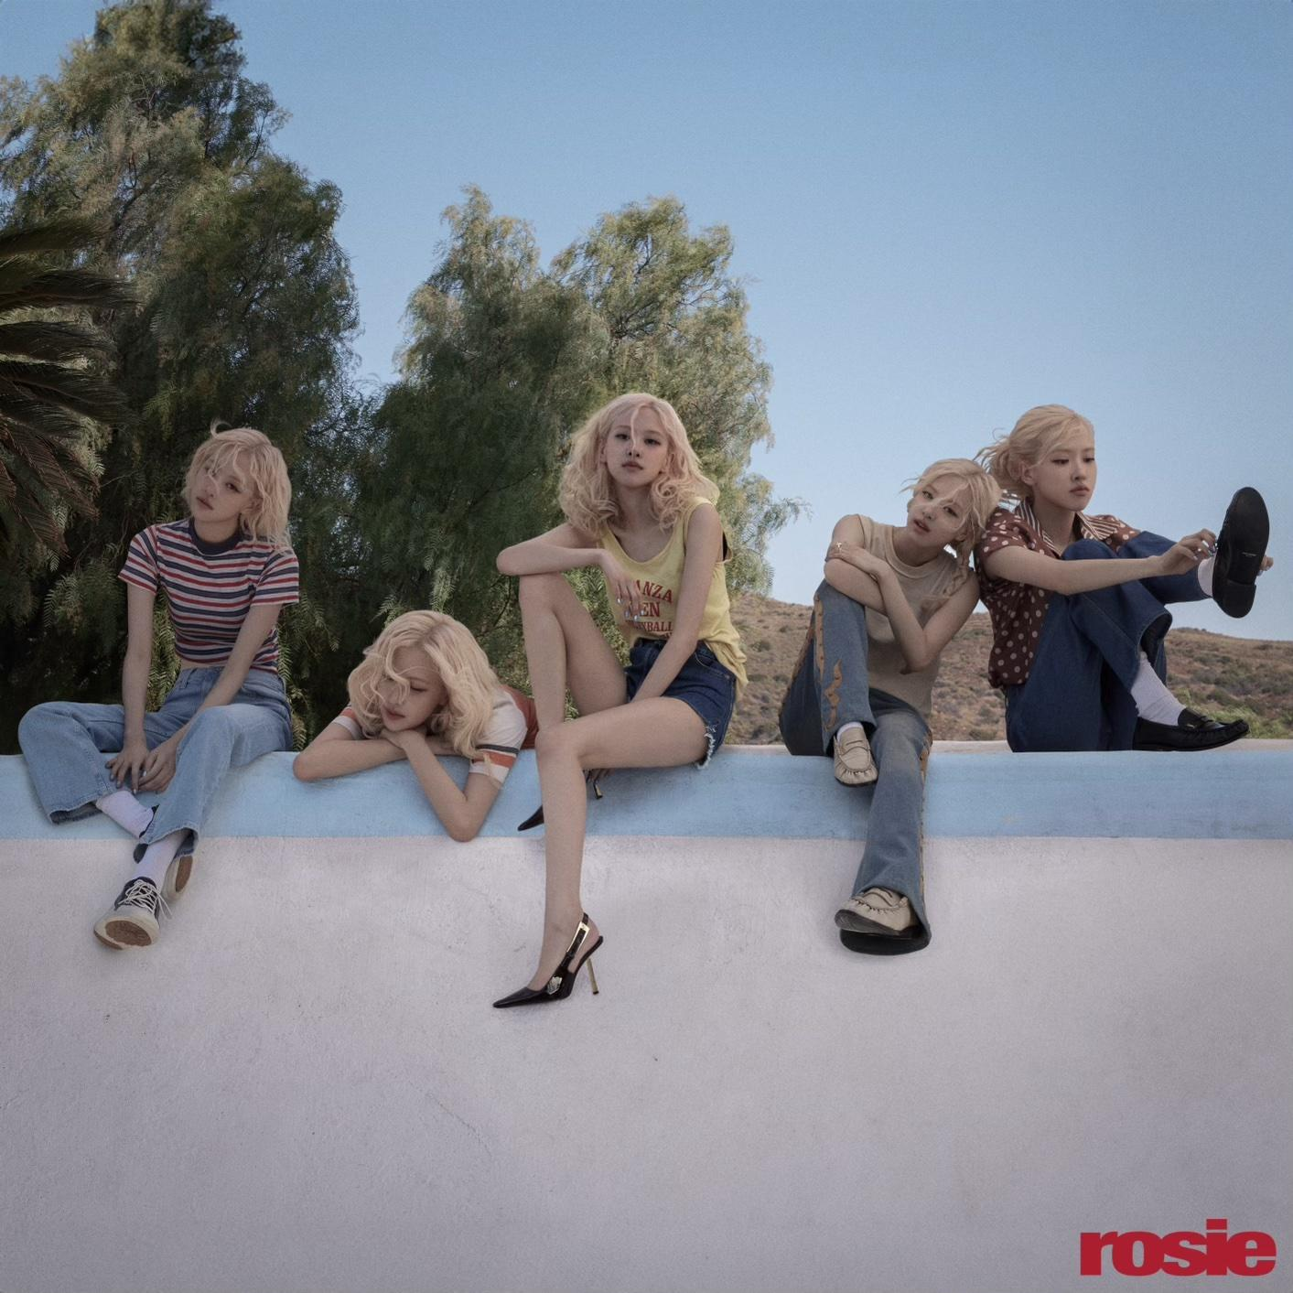

[DOWNLOAD HIGH-RES IMAGES](https://warnermusicgroup.box.com/s/90drelvfglgepqewvgq3q68zxfehaacn)

**CONNECT WITH ROSÉ:**

[RosesAreRosie.com](http://rosesarerosie.com) | [Instagram](https://www.instagram.com/roses_are_rosie/) | [TikTok](https://www.tiktok.com/@roses_are_rosie) | [X](https://x.com/numberonehq) | [YouTube](https://www.youtube.com/channel/UCBo1hnzxV9rz3WVsv__Rn1g/) | [Press Assets](https://warnermusicgroup.box.com/s/90drelvfglgepqewvgq3q68zxfehaacn)