**RODDY RICCH RELEASES “LONELY ROAD (FEAT. TERRACE MARTIN)”**

**OUT TODAY ALONGSIDE COMPANION VISUAL**

[**LISTEN**](https://roddyricch.lnk.to/LonelyRoad) **|** [**WATCH**](https://roddyricch.lnk.to/LonelyRoadVideo)

**ANNOUNCES THIRD STUDIO ALBUM ‘*THE* *NAVY ALBUM’* DUE OUT IN 2025**

***TURBO-PRODUCED NEW SONG SERVES AS PREVIEW TO DIAMOND-CERTIFIED SUPERSTAR’S NEW ALBUM***

[**PRE-ORDER: ‘THE NAVY ALBUM’**](https://roddyricch.lnk.to/THENAVYALBUM)

**RAP SUPERSTAR TO CELEBRATE 5 YEAR ANNIVERSARY OF ACCLAIMED ALBUM, *PLEASE EXCUSE ME FOR BEING ANTISOCIAL*,**

**WITH SOLD-OUT, HOMETOWN CONCERT EXPERIENCE SET FOR TONIGHT, DECEMBER 6 AT HOLLYWOOD PALLADIUM**

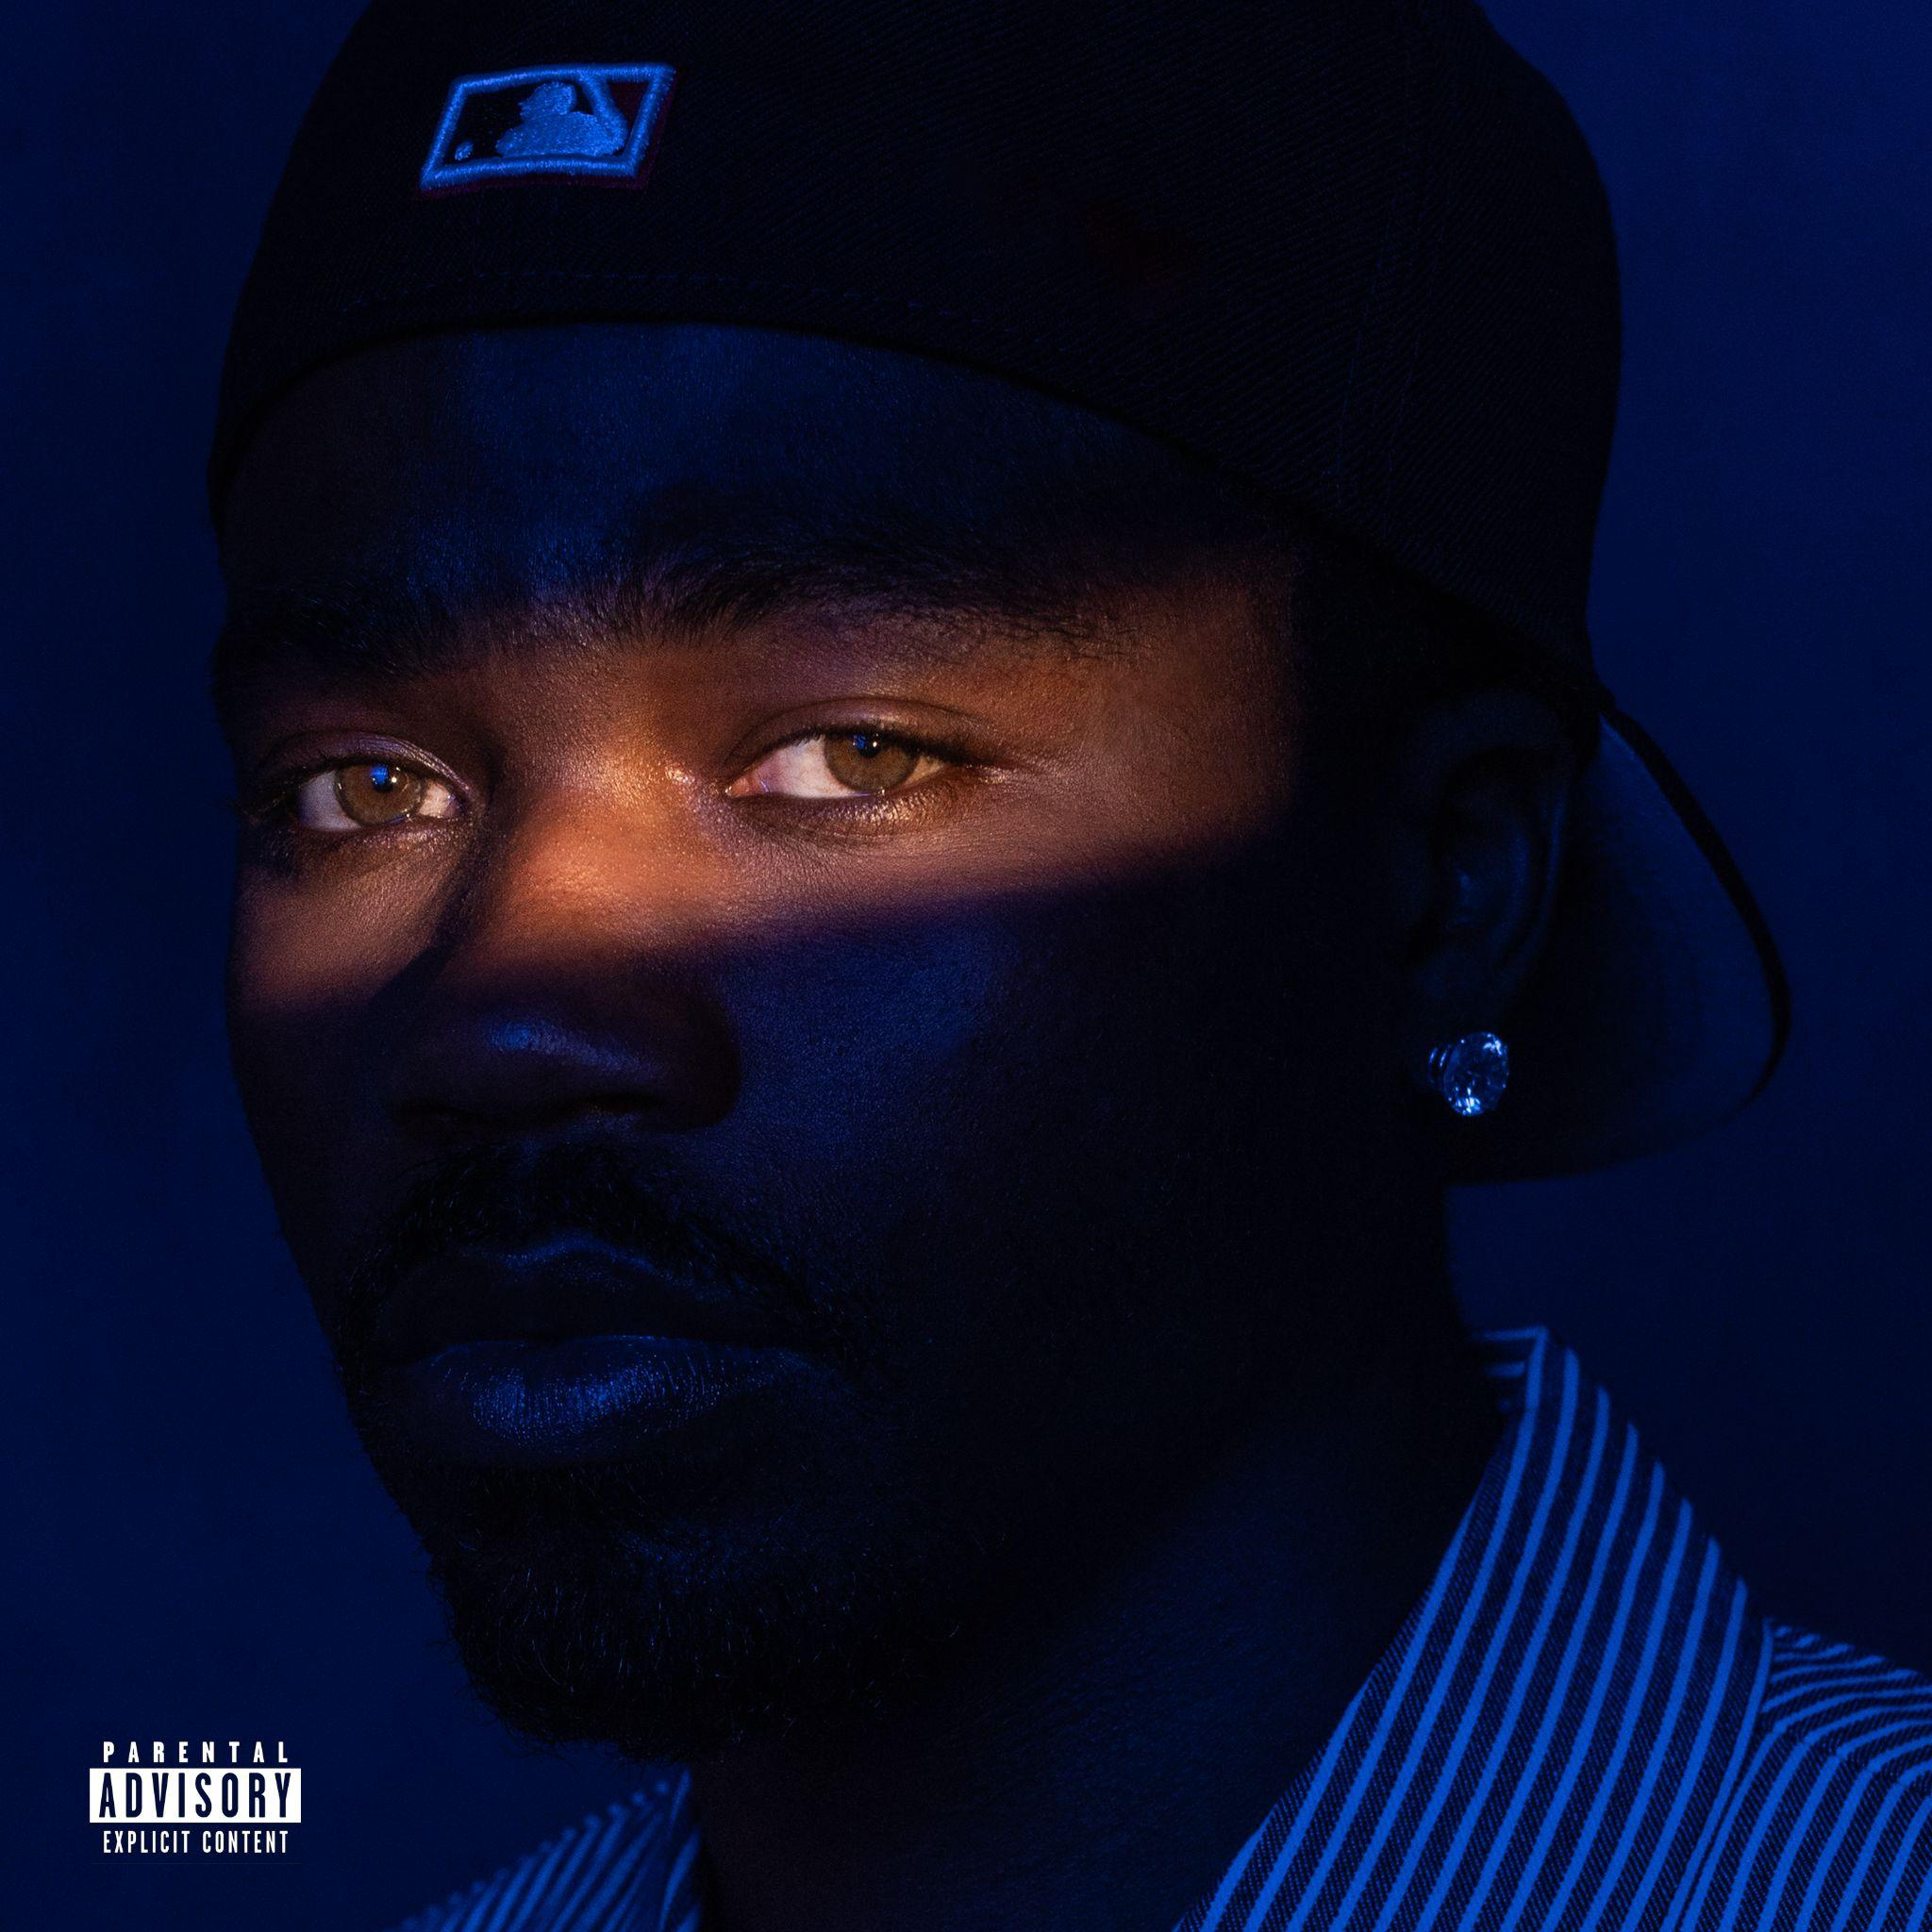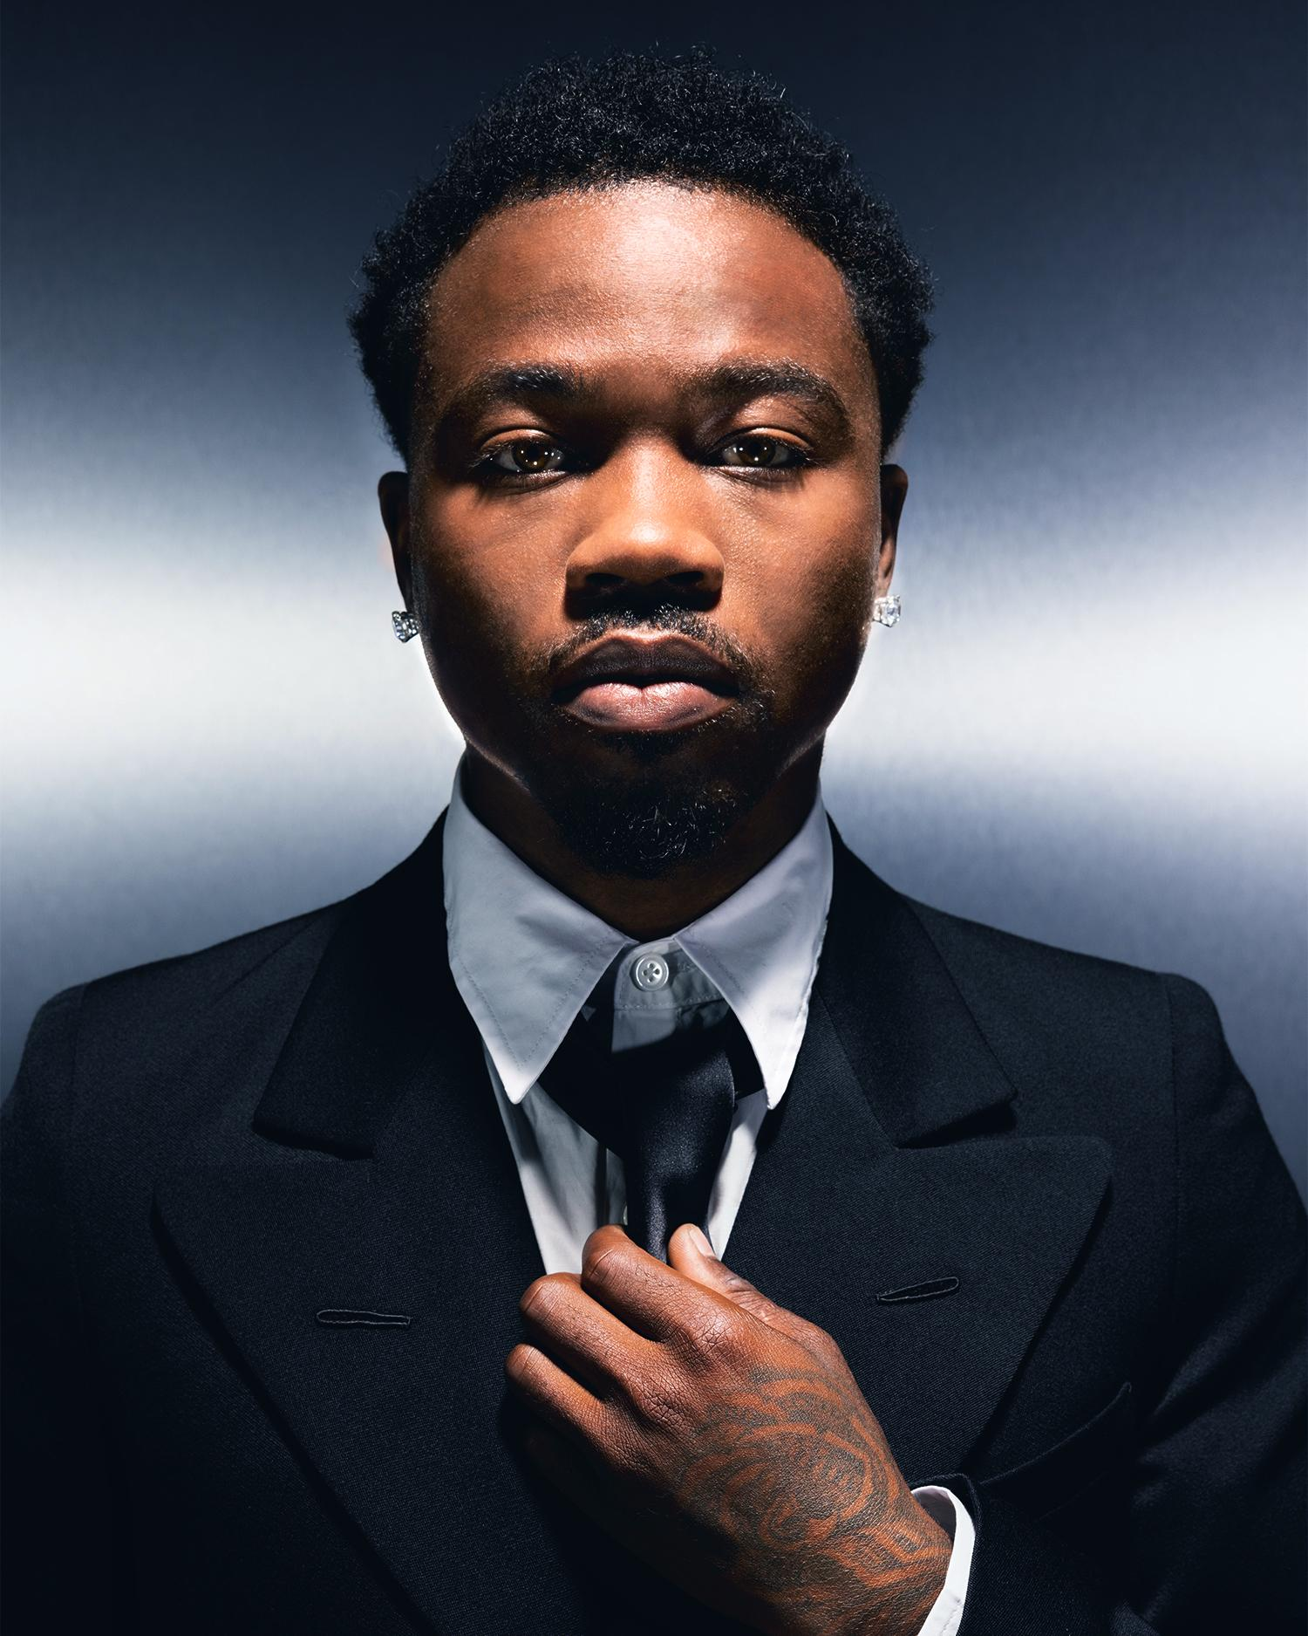

[DOWNLOAD](https://warnermusicgroup.box.com/s/1gpvs05q23d4d9jb3m6f6e5z3yfjtss7) HI-RES ARTWORK & PRESS IMAGE

PRESS IMAGE CREDIT: SAMY LACRAPULE

**December 6, 2024 (Los Angeles, CA) -** Diamond-certified rapper & West Coast icon **Roddy Ricch** has released **“Lonely Road (feat. Terrace Martin),”** out today, alongside a cinematic companion visual, via Atlantic Records. [**Listen**](https://roddyricch.lnk.to/LonelyRoad)&[**Watch**](https://roddyricch.lnk.to/LonelyRoadVideo).

The song – which sees Ricch joining forces with acclaimed producer/artist **Terrace Martin** (Kendrick Lamar, Snoop Dogg) with production from **Turbo** (Travis Scott, Gunna, Young Thug) – serves as a preview to Roddy’s forthcoming third studio album, ***THE NAVY ALBUM***, due out in 2025. [Pre-order](https://roddyricch.lnk.to/THENAVYALBUM) for *‘****THE NAVY ALBUM****’* is available now.

Both the release of “Lonely Road” and the announcement of ***THE NAVY ALBUM***, arrive ahead of the GRAMMY® winning superstar celebrating the 5 year anniversary of his blockbuster album, ***PLEASE EXCUSE ME FOR BEING ANTISOCIAL***, with a sold-out, hometown show set for tonight, December 6 at Los Angeles’ Hollywood Palladium.

* * *

With nearly 13B global streams to date, Roddy Ricch made his momentous, record-setting breakthrough with 2019’s 2x RIAA Platinum-certified, chart-topping album, [*PLEASE EXCUSE ME FOR BEING ANTISOCIAL*](https://roddyricch.lnk.to/PleaseExcuseMeForBeingAntisocial), highlighted by 11 RIAA certified hit singles including the 3x GRAMMY® Award-nominated, Diamond-certified #1 classic, “[The Box](https://www.youtube.com/watch?v=UNZqm3dxd2w&ab_channel=RoddyRicch),” joined by an equally successful official music video now approaching 1B. *PLEASE EXCUSE ME FOR BEING ANTISOCIAL* and “The Box” both made chart history, dominating as the #1 album and #1 song for three non-consecutive weeks, with “The Box” further ruling atop *Billboard*’s “Hot 100” for 11 consecutive weeks. Ricch then scored his second straight #1, replacing himself atop the “Hot 100” with his feature on DaBaby’s 5x Platinum single, “Rockstar,” which spent seven non-consecutive weeks at the top of the overall chart.

Hailed by *Pitchfork* as “*the West Coast’s premier melodic storyteller*,” Ricch is undoubtedly an exceptional musical force, a fact made clear by the 2020 “Best Rap Performance” GRAMMY® Award triumph for Nipsey Hussle’s “[Racks In The Middle (Feat. Roddy Ricch & Hit-Boy)](https://youtu.be/PAcGg_4KKYs?si=NLmm-YpmO4v3le8x),” along with nominations for “Best Rap Song” (for “Racks In The Middle”) and a “Best Rap/Sung Performance'' nod for Mustard’s smash single, “[Ballin (Feat. Roddy Ricch)](https://youtu.be/YS0h2-hy9rw?si=DQlhZtU0ZRQniZj4).” “The Box” and “Rockstar'' received each three nominations at the following year’s GRAMMY® Awards, including “Song of the Year” (“The Box”) and “Record of the Year” (“Rockstar”), with both named among the “Best Melodic Rap Performance” and “Best Rap Song” nominees. Additional honors include an American Music Award, two BET Hip Hop Awards, and two BET Awards (including “Album of the Year” for *PLEASE EXCUSE ME FOR BEING ANTISOCIAL*).

2024’s critically acclaimed arrival of “Survivor’s Remorse” and “911” marked the commencement of a major new chapter for the GRAMMY® Award-winning superstar. Ricch’s landmark year was further highlighted with an unforgettable performance at Kendrick Lamar’s acclaimed *The Pop Out: Ken & Friends* Juneteenth event in Inglewood. Most recently, Roddy appeared on, “[Dodger Blue (Feat. Wallie the Sensei, Siete7x, and Roddy Ricch)](https://www.youtube.com/watch?v=c7y2ziOBA1s&ab_channel=KendrickLamar),” the standout song from Kendrick Lamar’s latest album, *GNX*.

Now, with *THE NAVY ALBUM* and what promises to be a truly epic 2025, Roddy Ricch stakes his claim among the most consequential artists of his generation, affirming once again his singular mastery of melodic rap and emotionally charged lyrical storytelling.

**For all press inquiries, please contact:**

Jason Davis | [jason.davis@atlanticrecords.com](mailto:jason.davis@atlanticrecords.com)

# # #

**CONNECT WITH RODDY RICCH**

[OFFICIAL](https://www.roddyricchofficial.com/) | [FACEBOOK](https://www.facebook.com/RoddyRicch/) | [INSTAGRAM](https://www.instagram.com/roddyricch/) | [TIKTOK](https://www.tiktok.com/@roddyricch) | [TWITTER](https://twitter.com/RoddyRicch) | [YOUTUBE](https://www.youtube.com/channel/UChQdA1rid5kKZh6oIc6DLNg)